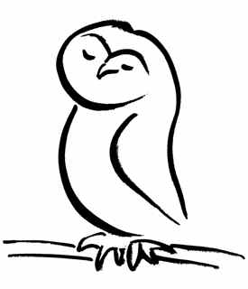
New Hampshire Association
of Conservation Commissions
SERVING NEW HAMPSHIRE’S COMMUNITIES SINCE 1970
54 Portsmouth Street, Concord, NH 03301 | (603) 224-7867 | www.nhacc.org

Minutes of the Annual Meeting
November 2, 2024 8:30 am
Board Members in Attendance: Lesley Johnson (P), Paul Wainwright (VP), Kristen Murphy (S), Jennifer Beck, Eileen Chabot, Linda Hansen, Lisa Morin, Larry Spencer and Steve Wingate.

Staff: Barbara Richter

Absent: Michael Cohen, Jay Diener, Michelle Lowe

Call to Order: Lesley called the meeting to order at 8:30 a.m. and welcomed attendees and introduced the board members.

Executive Director Remarks:
Barbara Richter shared gratitude for Conservation Commissions and their relentless efforts in natural resource protection. She also remarked appreciation for the new generation and their prioritization of the natural world. She emphasized the on-going need for balanced use of conservation land for people and resources. She highlighted the impressive track record of conservation commissions. She also provided some remarks on the role of NHACC and the past year in review. In 2024 NHACC participated on 14 separate committees, delivered the electronic newsletter to 1600 subscribers, introduced the NHACC Exchange an electronic list-serv for our members, tracked 28 bills and provided individual testimony on 8 of them. NHACC hosted a wetland ecology program which is now available online via our YouTube channel, and provided in person training on easement monitoring. She thanks Commissions state-wide for their commitment, time and energy.

Consent Agenda

Lesley referred members to the minutes, financials, presented the slate of officers as well as the new members as recommended by the Nominating Committee.

Motion by Zachary Boyajian (Chichester) to approve the consent agenda, 2nd by Paul Wainwright (Atkinson). Motion passed unanimously.

Adjourn

With no further business, Lesley Johnson declared the meeting adjourned.

Respectfully submitted, Kristen Murphy

